ELEN 161 Project 2

Completed by Holden Gordon and Jacob Taub

**Problem 1, 2, and 3:**

System 1: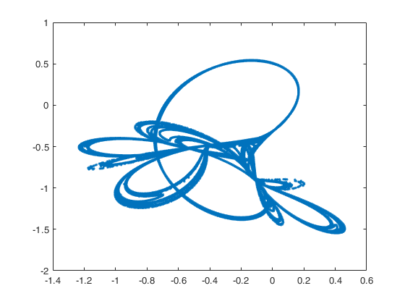

|  |  |  |  |  |  |  |  |  |  |
| --- | --- | --- | --- | --- | --- | --- | --- | --- | --- |
| Box | 2^4 | 2^5 | 2^6 | 2^7 | 2^8 | 2^9 | 2^10 | 2^11 | 2^12 |
| 10^5 | 1.4885 | 1.4819 | 1.4625 | 1.4541 | 1.4361 | 1.4092 | 1.3717 | 1.3255 | 1.2707 |
| 10^6 | 1.4943 | 1.4902 | 1.4742 | 1.4721 | 1.4703 | 1.4607 | 1.4445 | 1.4229 | 1.3931 |
| 10^7 | 1.4943 | 1.4919 | 1.4779 | 1.4789 | 1.4850 | 1.4870 | 1.4842 | 1.4744 | 1.4595 |

|  |  |  |  |  |  |  |  |  |  |
| --- | --- | --- | --- | --- | --- | --- | --- | --- | --- |
| Info | 2^4 | 2^5 | 2^6 | 2^7 | 2^8 | 2^9 | 2^10 | 2^11 | 2^12 |
| 10^5 | 1.2728 | 1.2417 | 1.2450 | 1.2425 | 1.2403 | 1.2403 | 1.2375 | 1.2305 | 1.2108 |
| 10^6 | 1.2745 | 1.2437 | 1.2467 | 1.2448 | 1.2441 | 1.2477 | 1.2521 | 1.2586 | 1.2604 |
| 10^7 | 1.2741 | 1.2426 | 1.2460 | 1.2440 | 1.2435 | 1.2475 | 1.2529 | 1.2619 | 1.2689 |

System 2: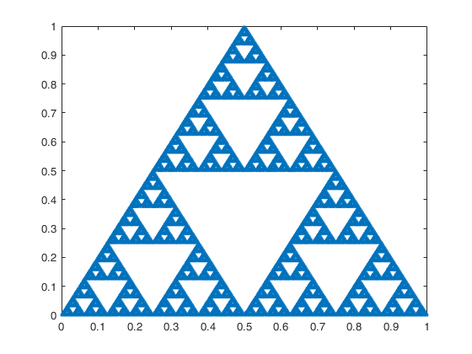

|  |  |  |  |  |  |  |  |  |  |
| --- | --- | --- | --- | --- | --- | --- | --- | --- | --- |
| Box | 2^4 | 2^5 | 2^6 | 2^7 | 2^8 | 2^9 | 2^10 | 2^11 | 2^12 |
| 10^5 | 1.6887 | 1.6680 | 1.6541 | 1.6443 | 1.6368 | 1.6243 | 1.5741 | 1.4804 | 1.3748 |
| 10^6 | 1.6887 | 1.6680 | 1.6541 | 1.6443 | 1.6368 | 1.6311 | 1.6264 | 1.6185 | 1.5814 |
| 10^7 | 1.6887 | 1.6680 | 1.6541 | 1.6443 | 1.6368 | 1.6311 | 1.6265 | 1.6227 | 1.6195 |

|  |  |  |  |  |  |  |  |  |  |
| --- | --- | --- | --- | --- | --- | --- | --- | --- | --- |
| Info | 2^4 | 2^5 | 2^6 | 2^7 | 2^8 | 2^9 | 2^10 | 2^11 | 2^12 |
| 10^5 | 1.6684 | 1.6514 | 1.6396 | 1.6297 | 1.6187 | 1.5987 | 1.5535 | 1.4705 | 1.3713 |
| 10^6 | 1.6682 | 1.6515 | 1.6404 | 1.6322 | 1.6258 | 1.6198 | 1.6125 | 1.5986 | 1.5642 |
| 10^7 | 1.6684 | 1.6516 | 1.6405 | 1.6325 | 1.6265 | 1.6218 | 1.6177 | 1.6137 | 1.6084 |

System 3: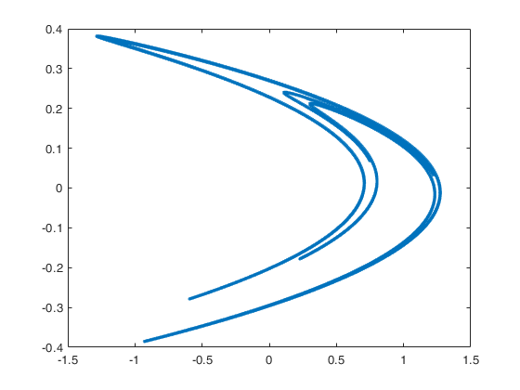

|  |  |  |  |  |  |  |  |  |  |
| --- | --- | --- | --- | --- | --- | --- | --- | --- | --- |
| Box | 2^4 | 2^5 | 2^6 | 2^7 | 2^8 | 2^9 | 2^10 | 2^11 | 2^12 |
| 10^5 | 1.2925 | 1.2951 | 1.2880 | 1.2821 | 1.2743 | 1.2687 | 1.2603 | 1.2533 | 1.2389 |
| 10^6 | 1.2925 | 1.2951 | 1.2880 | 1.2825 | 1.2759 | 1.2706 | 1.2647 | 1.2622 | 1.2645 |
| 10^7 | 1.2925 | 1.2951 | 1.2880 | 1.2825 | 1.2762 | 1.2709 | 1.2654 | 1.2632 | 1.2663 |

|  |  |  |  |  |  |  |  |  |  |
| --- | --- | --- | --- | --- | --- | --- | --- | --- | --- |
| Info | 2^4 | 2^5 | 2^6 | 2^7 | 2^8 | 2^9 | 2^10 | 2^11 | 2^12 |
| 10^5 | 1.2152 | 1.2200 | 1.2160 | 1.2225 | 1.2228 | 1.2239 | 1.2169 | 1.2117 | 1.2027 |
| 10^6 | 1.2154 | 1.2207 | 1.2166 | 1.2229 | 1.2240 | 1.2264 | 1.2218 | 1.2216 | 1.2253 |
| 10^7 | 1.2156 | 1.2210 | 1.2169 | 1.2231 | 1.2243 | 1.2268 | 1.2225 | 1.2228 | 1.2276 |

System 4: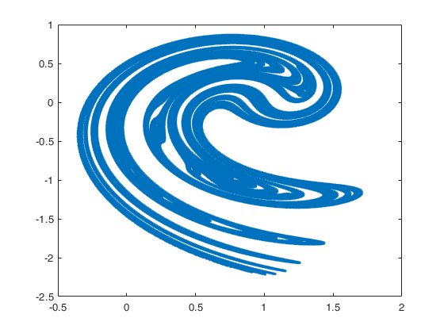

|  |  |  |  |  |  |  |  |  |  |
| --- | --- | --- | --- | --- | --- | --- | --- | --- | --- |
| Box | 2^4 | 2^5 | 2^6 | 2^7 | 2^8 | 2^9 | 2^10 | 2^11 | 2^12 |
| 10^5 | 1.4767 | 1.5185 | 1.5521 | 1.5740 | 1.5862 | 1.5847 | 1.5513 | 1.4723 | 1.3724 |
| 10^6 | 1.4767 | 1.5215 | 1.5581 | 1.5803 | 1.5968 | 1.6074 | 1.6129 | 1.6074 | 1.5731 |
| 10^7 | 1.4827 | 1.5244 | 1.5600 | 1.5820 | 1.5997 | 1.6123 | 1.6218 | 1.6283 | 1.6299 |

|  |  |  |  |  |  |  |  |  |  |
| --- | --- | --- | --- | --- | --- | --- | --- | --- | --- |
| Info | 2^4 | 2^5 | 2^6 | 2^7 | 2^8 | 2^9 | 2^10 | 2^11 | 2^12 |
| 10^5 | 1.3676 | 1.4422 | 1.4902 | 1.5196 | 1.5387 | 1.5453 | 1.5240 | 1.4598 | 1.3681 |
| 10^6 | 1.3676 | 1.4424 | 1.4906 | 1.5217 | 1.5441 | 1.5622 | 1.5731 | 1.5729 | 1.5496 |
| 10^7 | 1.3674 | 1.4424 | 1.4907 | 1.5219 | 1.5446 | 1.5638 | 1.5782 | 1.5883 | 1.5943 |

System 5: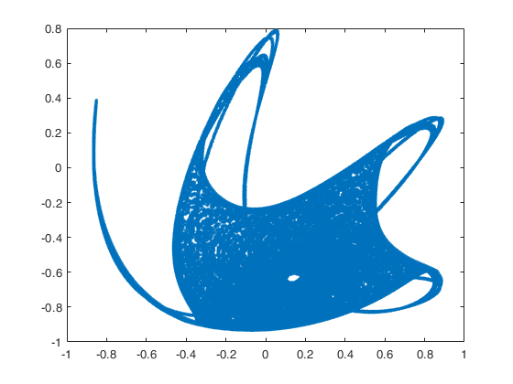

|  |  |  |  |  |  |  |  |  |  |
| --- | --- | --- | --- | --- | --- | --- | --- | --- | --- |
| Box | 2^4 | 2^5 | 2^6 | 2^7 | 2^8 | 2^9 | 2^10 | 2^11 | 2^12 |
| 10^5 | 1.7297 | 1.7008 | 1.7058 | 1.7230 | 1.7207 | 1.6700 | 1.5831 | 1.4787 | 1.3724 |
| 10^6 | 1.7297 | 1.7024 | 1.7070 | 1.7255 | 1.7448 | 1.7533 | 1.7279 | 1.6702 | 1.5921 |
| 10^7 | 1.7297 | 1.7031 | 1.7074 | 1.7259 | 1.7459 | 1.7635 | 1.7700 | 1.7575 | 1.7230 |

|  |  |  |  |  |  |  |  |  |  |
| --- | --- | --- | --- | --- | --- | --- | --- | --- | --- |
| Info | 2^4 | 2^5 | 2^6 | 2^7 | 2^8 | 2^9 | 2^10 | 2^11 | 2^12 |
| 10^5 | 1.6100 | 1.6269 | 1.6394 | 1.6467 | 1.6395 | 1.6107 | 1.5515 | 1.4649 | 1.3672 |
| 10^6 | 1.6025 | 1.6205 | 1.6347 | 1.6453 | 1.6488 | 1.6484 | 1.6387 | 1.6104 | 1.5593 |
| 10^7 | 1.6025 | 1.6207 | 1.6353 | 1.6462 | 1.6507 | 1.6533 | 1.6533 | 1.6481 | 1.6353 |

System 6: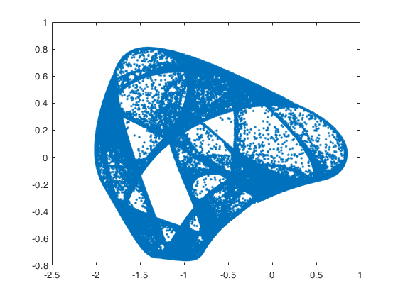

|  |  |  |  |  |  |  |  |  |  |
| --- | --- | --- | --- | --- | --- | --- | --- | --- | --- |
| Box | 2^4 | 2^5 | 2^6 | 2^7 | 2^8 | 2^9 | 2^10 | 2^11 | 2^12 |
| 10^5 | 1.5759 | 1.6121 | 1.6476 | 1.6620 | 1.6537 | 1.6189 | 1.5534 | 1.4656 | 1.3682 |
| 10^6 | 1.5759 | 1.6143 | 1.6551 | 1.6915 | 1.7141 | 1.7150 | 1.6965 | 1.6543 | 1.5871 |
| 10^7 | 1.5759 | 1.6143 | 1.6559 | 1.6935 | 1.7264 | 1.7512 | 1.7597 | 1.7506 | 1.7250 |

|  |  |  |  |  |  |  |  |  |  |
| --- | --- | --- | --- | --- | --- | --- | --- | --- | --- |
| Info | 2^4 | 2^5 | 2^6 | 2^7 | 2^8 | 2^9 | 2^10 | 2^11 | 2^12 |
| 10^5 | 1.4058 | 1.4411 | 1.4687 | 1.4959 | 1.5189 | 1.5256 | 1.5030 | 1.4446 | 1.3610 |
| 10^6 | 1.4051 | 1.4412 | 1.4696 | 1.4993 | 1.5298 | 1.5569 | 1.5758 | 1.5763 | 1.5473 |
| 10^7 | 1.4044 | 1.4404 | 1.4691 | 1.4995 | 1.5309 | 1.5609 | 1.5882 | 1.6103 | 1.6222 |

System 7:

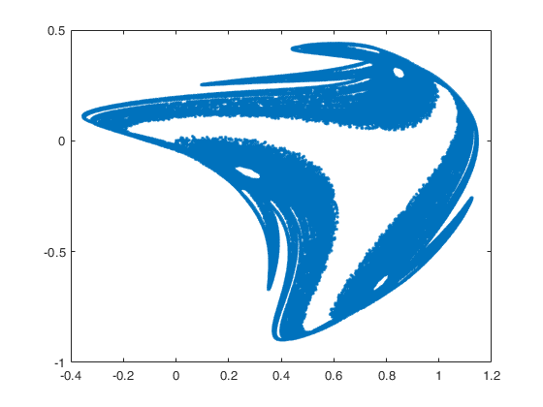

|  |  |  |  |  |  |  |  |  |  |
| --- | --- | --- | --- | --- | --- | --- | --- | --- | --- |
| Box | 2^4 | 2^5 | 2^6 | 2^7 | 2^8 | 2^9 | 2^10 | 2^11 | 2^12 |
| 10^5 | 1.4320 | 1.4552 | 1.4943 | 1.5310 | 1.5639 | 1.5719 | 1.5377 | 1.4631 | 1.3670 |
| 10^6 | 1.4387 | 1.4644 | 1.4991 | 1.5370 | 1.5730 | 1.6029 | 1.6215 | 1.6149 | 1.5724 |
| 10^7 | 1.4387 | 1.4715 | 1.5051 | 1.5421 | 1.5781 | 1.6096 | 1.6351 | 1.6546 | 1.6624 |

|  |  |  |  |  |  |  |  |  |  |
| --- | --- | --- | --- | --- | --- | --- | --- | --- | --- |
| Info | 2^4 | 2^5 | 2^6 | 2^7 | 2^8 | 2^9 | 2^10 | 2^11 | 2^12 |
| 10^5 | 1.1294 | 1.2125 | 1.2815 | 1.3467 | 1.4006 | 1.4368 | 1.4476 | 1.4175 | 1.3940 |
| 10^6 | 1.1321 | 1.2144 | 1.2834 | 1.3487 | 1.4042 | 1.4470 | 1.4800 | 1.5 | 1.4975 |
| 10^7 | 1.1331 | 1.2155 | 1.2842 | 1.3492 | 1.4047 | 1.4481 | 1.4835 | 1.5116 | 1.5332 |

System 8:

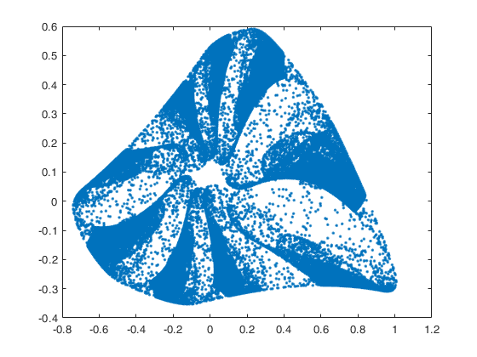

|  |  |  |  |  |  |  |  |  |  |
| --- | --- | --- | --- | --- | --- | --- | --- | --- | --- |
| Box | 2^4 | 2^5 | 2^6 | 2^7 | 2^8 | 2^9 | 2^10 | 2^11 | 2^12 |
| 10^5 | 1.6189 | 1.6515 | 1.6801 | 1.6777 | 1.6452 | 1.6025 | 1.5458 | 1.4659 | 1.370 |
| 10^6 | 1.6230 | 1.6524 | 1.6908 | 1.7254 | 1.7375 | 1.72 | 1.686- | 1.6433 | 1.5843 |
| 10^7 | 1.6320 | 1.6524 | 1.6914 | 1.7273 | 1.7571 | 1.771 | 1.7743 | 1.7501 | 1.7158 |

|  |  |  |  |  |  |  |  |  |  |
| --- | --- | --- | --- | --- | --- | --- | --- | --- | --- |
| Info | 2^4 | 2^5 | 2^6 | 2^7 | 2^8 | 2^9 | 2^10 | 2^11 | 2^12 |
| 10^5 | 1.3393 | 1.3639 | 1.4052 | 1.4546 | 1.4885 | 1.5078 | 1.4969 | 1.4462 | 1.3638 |
| 10^6 | 1.3465 | 1.3709 | 1.4110 | 1.4615 | 1.5016 | 1.5378 | 1.5623 | 1.5698 | 1.5479 |
| 10^7 | 1.3478 | 1.3724 | 1.4127 | 1.4635 | 1.5045 | 1.5438 | 1.5765 | 1.6026 | 1.6182 |

System 9: 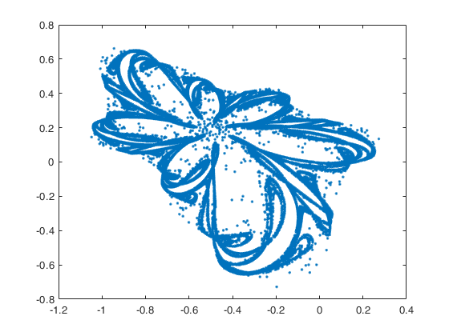

|  |  |  |  |  |  |  |  |  |  |
| --- | --- | --- | --- | --- | --- | --- | --- | --- | --- |
| Box | 2^4 | 2^5 | 2^6 | 2^7 | 2^8 | 2^9 | 2^10 | 2^11 | 2^12 |
| 10^5 | 1.5894 | 1.6121 | 1.6216 | 1.6033 | 1.5722 | 1.5313 | 1.4749 | 1.4048 | 1.3279 |
| 10^6 | 1.5981 | 1.6330 | 1.6598 | 1.6590 | 1.6366 | 1.6078 | 1.5784 | 1.5401 | 1.4890 |
| 10^7 | 1.6066 | 1.6370 | 1.6790 | 1.7033 | 1.7029 | 1.6805 | 1.6500 | 1.6195 | 1.5873 |

|  |  |  |  |  |  |  |  |  |  |
| --- | --- | --- | --- | --- | --- | --- | --- | --- | --- |
| Info | 2^4 | 2^5 | 2^6 | 2^7 | 2^8 | 2^9 | 2^10 | 2^11 | 2^12 |
| 10^5 | 1.4146 | 1.4284 | 1.4353 | 1.4335 | 1.4265 | 1.4147 | 1.3901 | 1.3510 | 1.2983 |
| 10^6 | 1.4143 | 1.4279 | 1.4351 | 1.4345 | 1.4302 | 1.4277 | 1.4221 | 1.4118 | 1.3936 |
| 10^7 | 1.4141 | 1.4275 | 1.4348 | 1.4343 | 1.4304 | 1.4291 | 1.4263 | 1.4320 | 1.418 |

The information gathered from the Box and Information dimensions shows multiple patterns. First, both the box and information dimensions decrease as the dimension of the grid goes up. Also, as, the number of points increases, both the box and information dimensions seem to increase; however, the information dimensions seems to increase at a much slower rate than the box dimension. As the box dimension increases, their is a limitation to have more information can be shown by just increasing the number of data points. The slope of the information dimension and box dimensions coalesce about a particular value and adding more seems to slow the increase of the slope in box and info dimensions but particularly in the information dimension. Overall the box and information dimensions have more points and become more accurate to a certain threshold; however, the information dimension starts to increase at significantly reduced rate because the data points are only coalescing further along the line.

**Problem 4**

System 2

|  |  |  |  |  |  |  |  |  |  |
| --- | --- | --- | --- | --- | --- | --- | --- | --- | --- |
| Box | 2^4 | 2^5 | 2^6 | 2^7 | 2^8 | 2^9 | 2^10 | 2^11 | 2^12 |
| 10^8 | 1.6066 | 1.6370 | 1.6790 | 1.7033 | 1.7029 | 1.6805 | 1.6500 | 1.6195 | 1.5873 |
| 10^9 | 1.6887 | 1.6680 | 1.689 | 1.701 | 1.7024 | 1.6793 | 1.6382 | 1.6791 | 1.6483 |

System 4

|  |  |  |  |  |  |  |  |  |  |
| --- | --- | --- | --- | --- | --- | --- | --- | --- | --- |
| Box | 2^4 | 2^5 | 2^6 | 2^7 | 2^8 | 2^9 | 2^10 | 2^11 | 2^12 |
| 10^8 | 1.4827 | 1.5224 | 1.56 | 1.5824 | 1.6007 | 1.6311 | 1.6265 | 1.6227 | 1.6195 |
| 10^9 | 1.4827 | 1.5244 | 1.5603 | 1.5812 | 1.6003 | 1.6142 | 1.6327 | 1.6378 | 1.6264 |

System 5

|  |  |  |  |  |  |  |  |  |  |
| --- | --- | --- | --- | --- | --- | --- | --- | --- | --- |
| Box | 2^4 | 2^5 | 2^6 | 2^7 | 2^8 | 2^9 | 2^10 | 2^11 | 2^12 |
| 10^8 | 1.7297 | 1.7031 | 1.7074 | 1.7261 | 1.7461 | 1.7643 | 1.7751 | 1.772 | 1.7711 |
| 10^9 | 1.7297 | 1.7031 | 1.7074 | 1.7261 | 1.7428 | 1.7642 | 1.750 | 1.773 | 1.771 |

System 9

|  |  |  |  |  |  |  |  |  |  |
| --- | --- | --- | --- | --- | --- | --- | --- | --- | --- |
| Box | 2^4 | 2^5 | 2^6 | 2^7 | 2^8 | 2^9 | 2^10 | 2^11 | 2^12 |
| 10^8 | 1.6107 | 1.6390 | 1.6830 | 1.7184 | 1.7411 | 1.7428 | 1.7236 | 1.6929 | 1.6593 |
| 10^9 | 1.6107 | 1.6390 | 1.6832 | 1.7207 | 1.7462 | 1.7645 | 1.7345 | 1.7483 | 1.679 |

For the most part, the systems look very similar, so the extra computational power may not be worth it to calculate these box dimensions. There was slight deviation in System 4 and 9 which may have been important, but it seems statistically insignificant. So, in it may not be necessary to go past 10^9, but it also depends on the system.

**Problem 5**

Here is the plot obtained from p versus F(p)

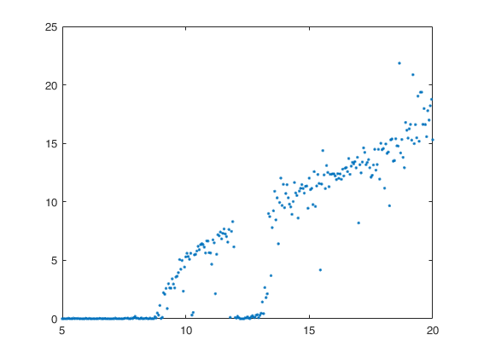

This system demonstrates choatic behavior (where F(p) > 0.3) at 0.95 - 11 and 12.95 onward

0.179-0.229 and

This is the system that is resulted from fixing p = 5.7 and sweeping q from -1 to 0.3 in steps of 0.005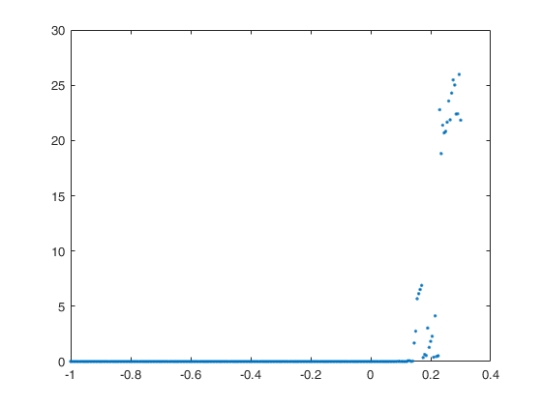

Here chaos occurs at 0.149-0.225 and the gap occurs between 0.179-0.222.

Here is the matlab plot of our strange attractor for chaotic values(10, 0.2). (It kind of even looks like a buttefly).

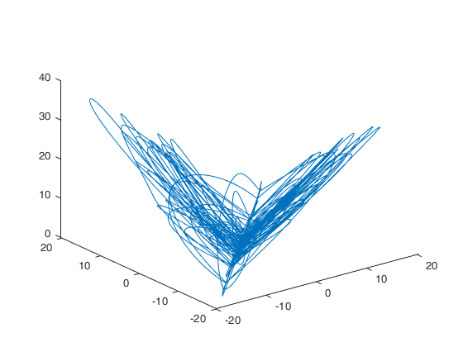

**Problem 6**

If x’ = -x^3x +3x -p,

Then f’(x’) = -3x^2 +3. The equilibria of this is system are -1 and 1. Therefore, anything between [-1,1] is unstable, while all other values are stable.

The associated p-values with these are

-(-1)^3 -3 - p = 0

And

-(1)^3 3 - p = 0

The p values are -2 and 2.

This is then seen in the below graph that manually solved for each point and graphed all of the roots. Note: imaginary numbers started to appear and numbers greater than -2 and 2.

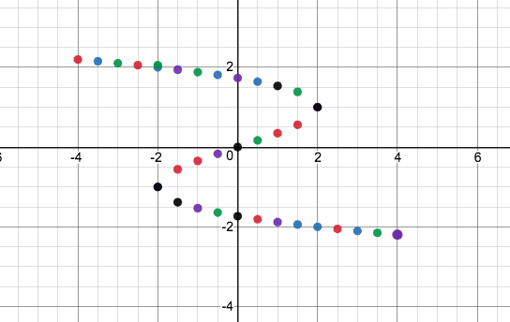

Between 2 and -2 there only exists one real root out of 3 possible solutions. Therfore, there is a catastrophe at p = -/+2.

All code referenced and written in this project can be found in the code appendix attached to the back.